Zoe Boyle

Lab 4- out of lab

1. Text

   Description automatically generated
2. 
3. 
   1. Graphical user interface, text, application

      Description automatically generated
   2. 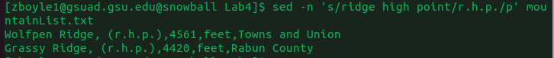
   3. -n only prints the processed lines
   4. it printed the only two lines processed by sed, without the duplicates like the first time
4. Text

   Description automatically generated
5. Text

   Description automatically generated
6. Text

   Description automatically generated
7. Text

   Description automatically generated
8. Text

   Description automatically generated
9. Text

   Description automatically generated
10. Text

    Description automatically generated
11. Text

    Description automatically generated
12. Text

    Description automatically generated
13. Text

    Description automatically generated
14. Text

    Description automatically generated